**Weight vector:**

W* is we call as weight vector   
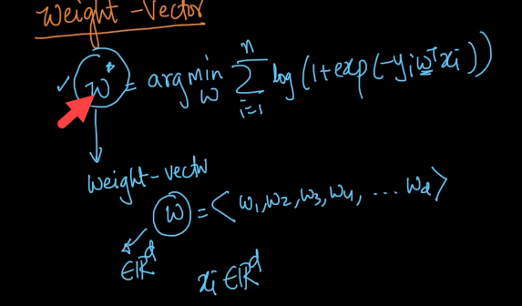  
For simplicity, we will call W* as W.   
W belongs to d-dimension, so we will have W = <W1,W2,W3, …Wd>  
**Interpretation of W**W = <W1,W2,W3…Wd>, we will have different features as well, let’s say f1,f2,f3…fd.  
So for every feature will be having some weight. For instance: f1 will have weight associated let’s say W2.  
Let’s assume we given new query point Xq and we need to find the class label Yq   
In using logistic regression, the basic assumptions are as below   
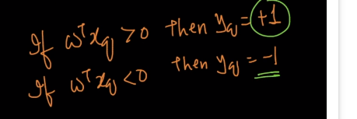  
**Case #1 :**  
If Wi = +ve 🡪 xqi increase, because the ith component of xq will be multiplied by ith component of Wi🡪(Wixqi) (Vector notation)increases🡪i=1∑d (Wixqi) (Scaler notation) increases🡪Sigmoid function increases🡪 P(Yq = +1) increases meaning probability of point being positive class increases  
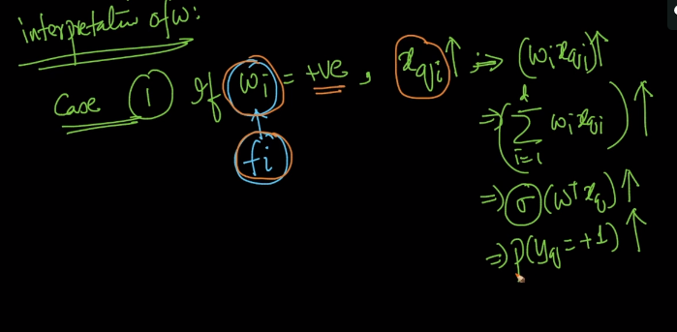  
**Case #2:**  
If Wi = -ve 🡪 xqi increases, because the ith component of xq will be multiplied by ith component of Wi🡪(Wixqi) (Vector notation)Decreases🡪i=1∑d (Wixqi) (Scaler notation) decreases🡪Sigmoid function decreases🡪 P(Yq = +1) increases meaning probability of point being negative class increases

Just to summarize, If the Wi corresponding to fi is -ve and xqi increases then probability of point being negative class increases and If the Wi corresponding to fi is +ve and xqi increases then probability of point being positive class increases